

|  |  |  |  |  |  |  |
| --- | --- | --- | --- | --- | --- | --- |
|  | | | | | | |
|  | | Exam Management System | | |  | |
|  |  | | | | |  |
|  | | |  |  | | |
|  | | | Object-Oriented ProgrammingPresented to:Dr. Shaimaa ElmorsyEng. Yasmina Kamal Done by:  Abdelrahman Ahmed 221000777 Class 9  Mohamed Walid 221001648  Class 9  Mostafa Nader 221000760  Class 9 |  | | |

|  |  |  |  |  |  |  |  |  |
| --- | --- | --- | --- | --- | --- | --- | --- | --- |
|  | |  |  | | |  |  | |
|  | | Report | | | | |  | |
|  | |  |  | | |  |  | |
|  | The Exam Management System being presented is designed to help educators in schools or universities in various ways. First of all, this system is well designed for professors and students to easily access. For professors, they can use their admin passwords to enter the system. Once a professor has accessed the system, he/she can carry out many tasks. They can create exams, edit them by adding or removing questions, creating various exam models, update exams, grade them and post the grades, etc…  For such a complex system to be designed, there are some requirements. A high availability database is needed to secure the system from easy access. Without it, students can easily enter the system and leak tests or other important information. It also ensures that the system maintains continuous operations uninterrupted even when facing issues such as network issues or hardware problems. Also, the database is connected to the system itself in such a professional way to always ensure easy and protected access. The system interphase in our exam management system authorizes professors to easily created quizzes in various models to prevent cheating. To sum up, our system is designed to allow teachers to create, edit exams and access grades without having to worry about students being able to get inside and find exam questions. Using a high availability database with a strong interphase our system ensures safe test creating and exam taking. | | | | | | |  |
|  | Here the admin entered a wrong password | | |  |  | | |  |
|  |  | | |  |  | | |  |

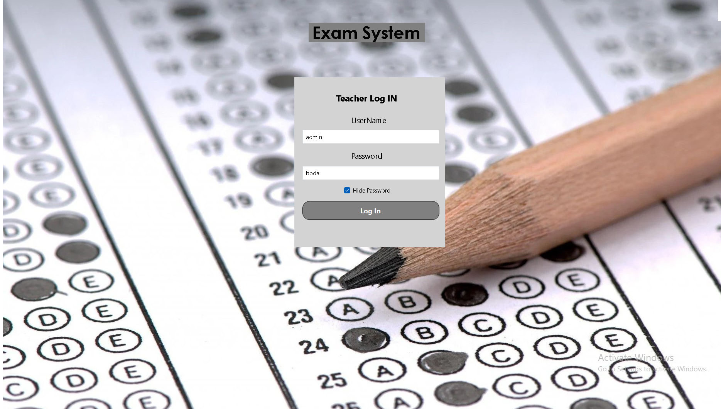

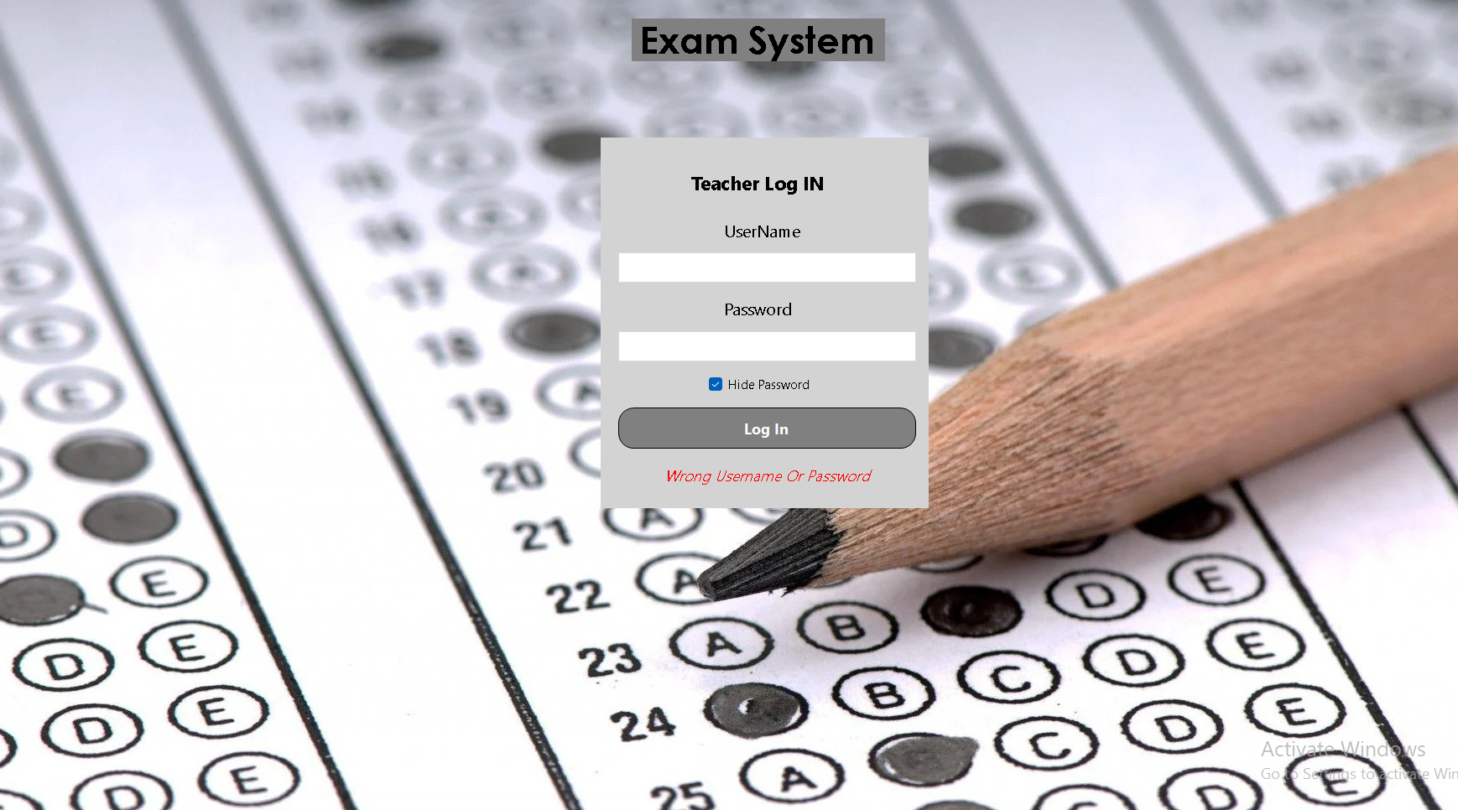Here the system send a message telling that this password is not correct

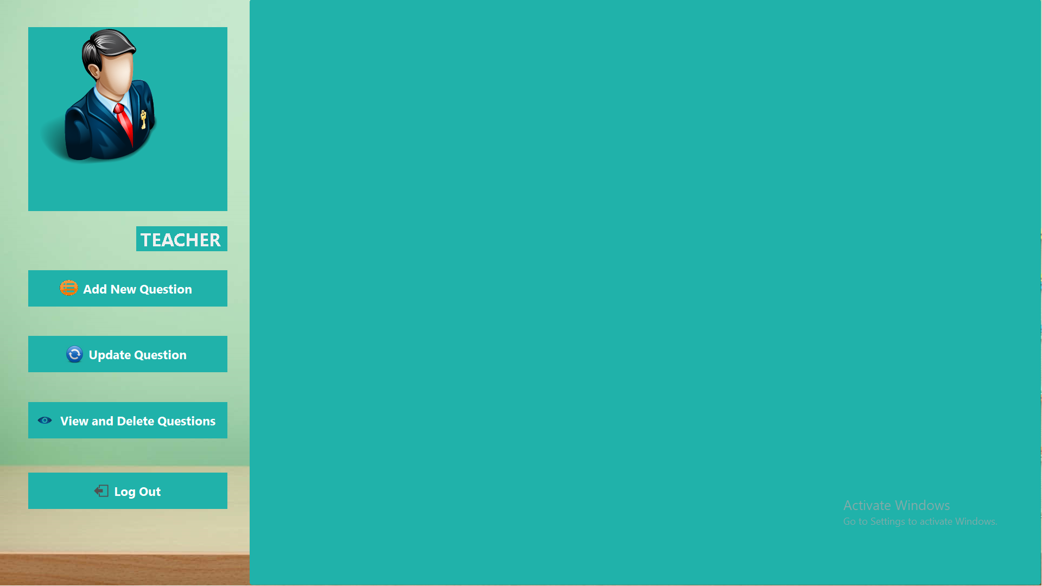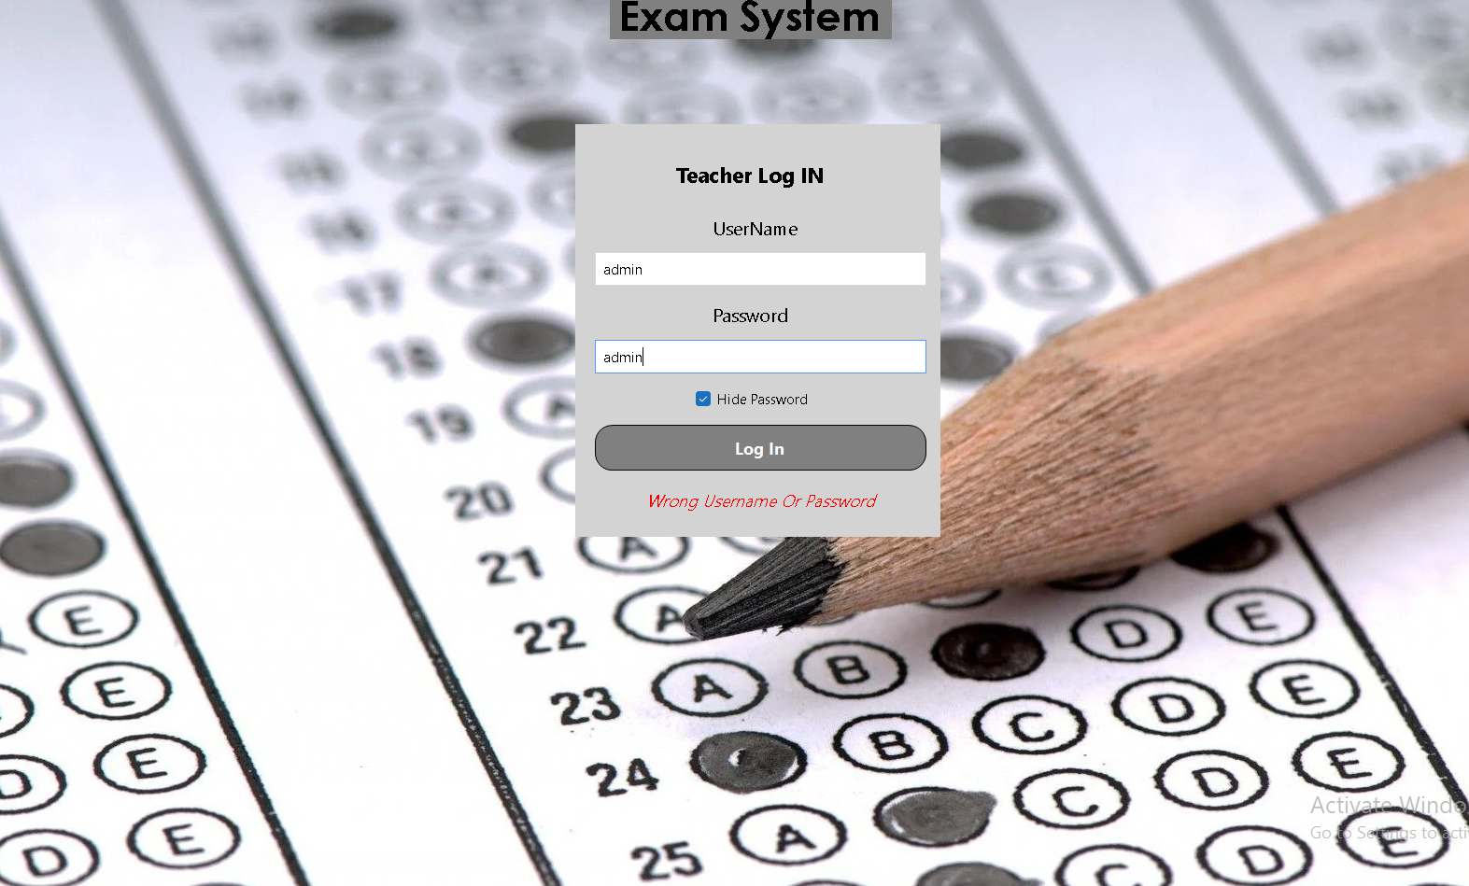Here when you entered the correct username and password you can enter the system properly to go the teacher form which here you can add and delete and update any question you want

Here in adding question you must put the model and the question and the options with the answer

Also here you can many models for your exam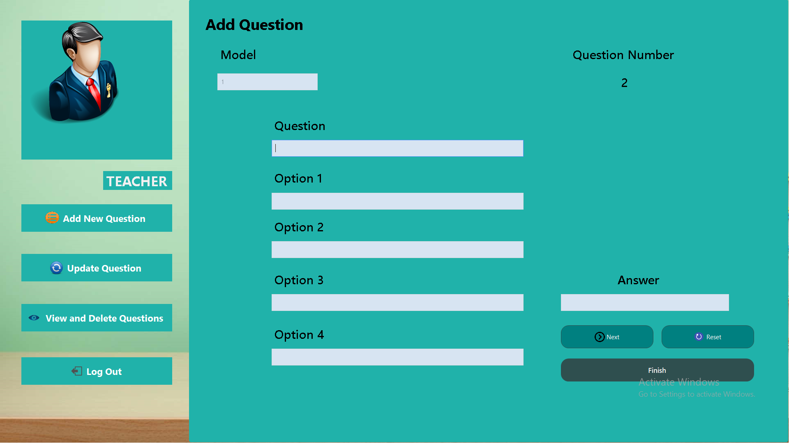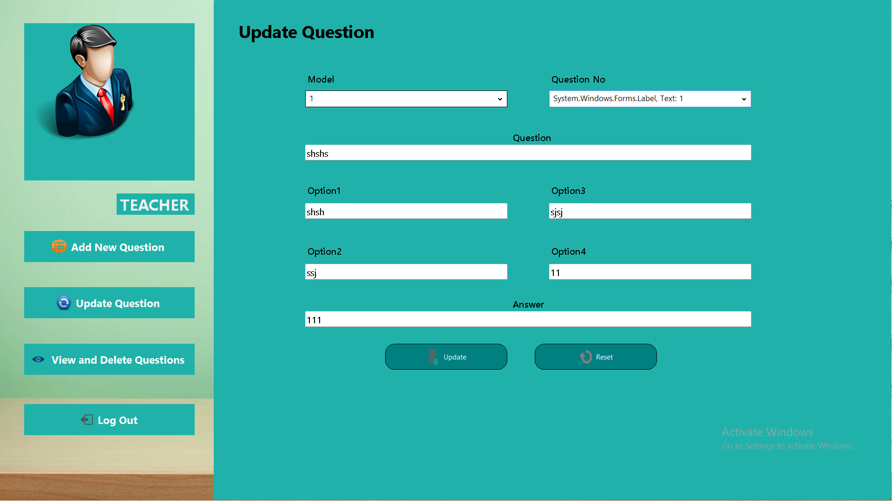 Here you are enabled for updating any question you want

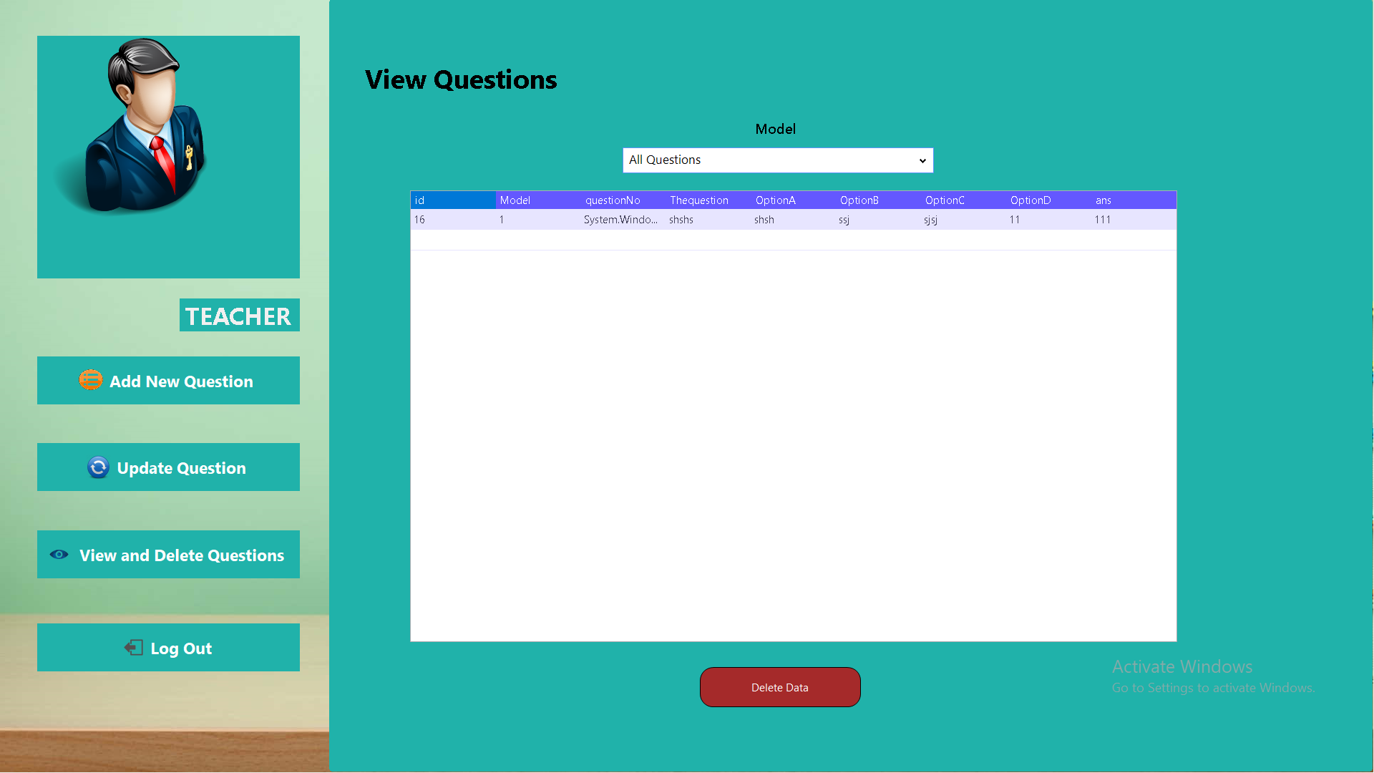Here you can view all your questions or each model only

Also you can delete any unneeded question.

And the log out option return you back to the first page